**Day – 1**

**DATA STRUCTURES – BASIC C PROGRAMMING - 1**

1. Write a c program to check the given numbers is even or odd.

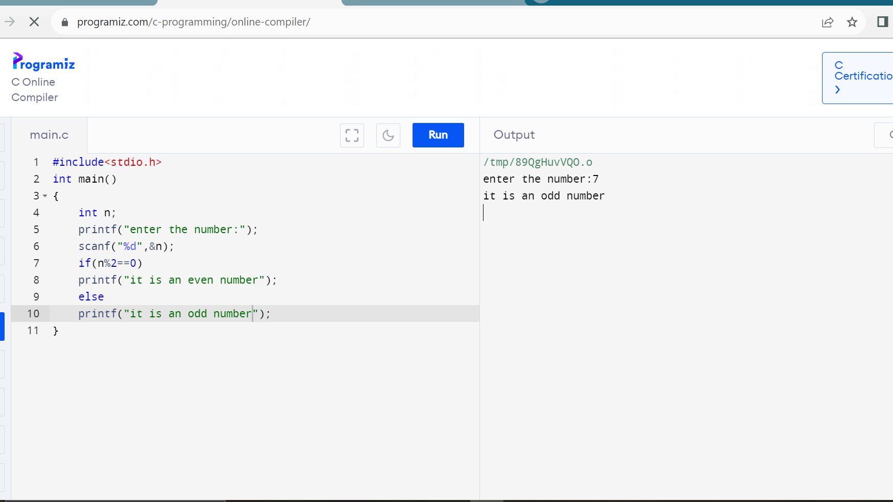

1. Write a c program to find the sum of first n numbers using for loop.

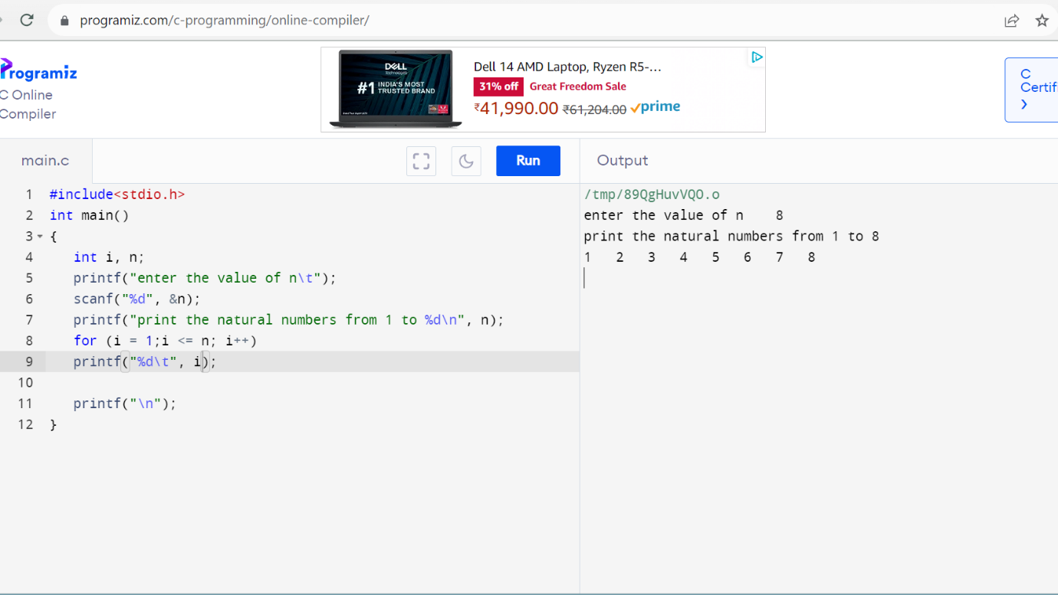

1. Write a c program to find sum of even numbers using while loop.

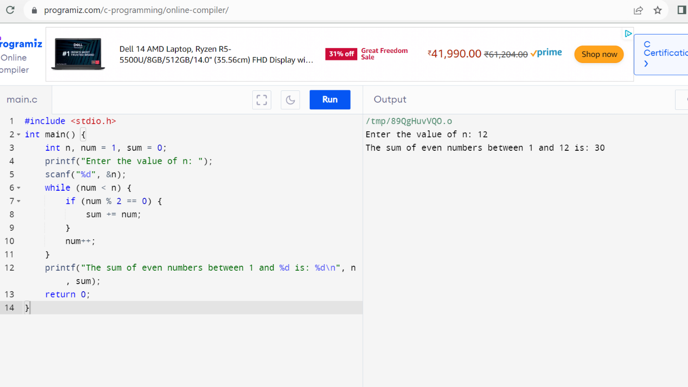

1. Write a c program to reverse a given number.

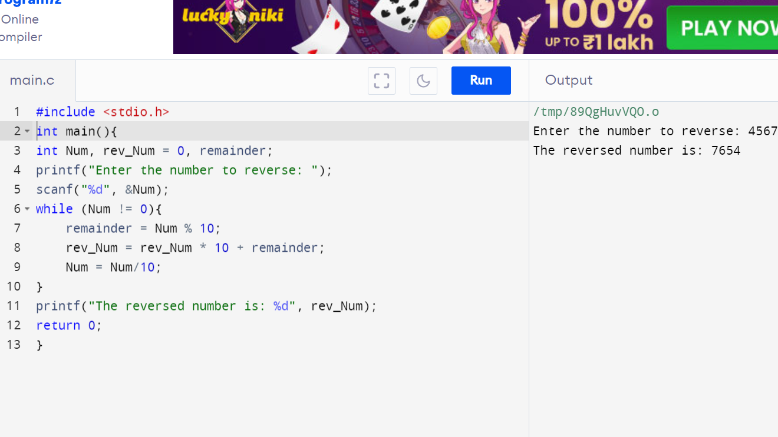

1. Write a c program to check the given numbers is palindrome or not.

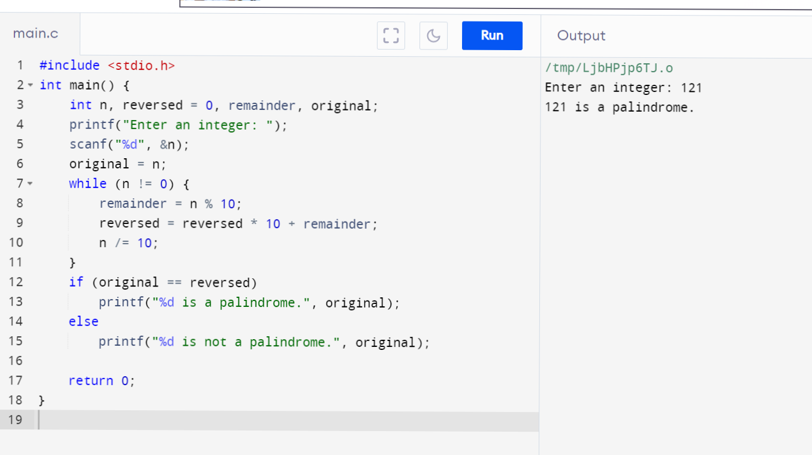

1. Write a c program to check the given number is Armstrong or not.

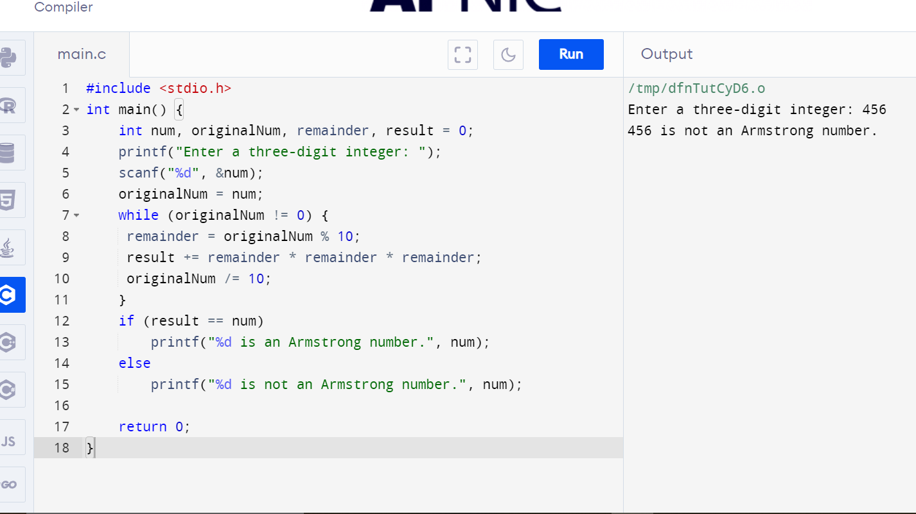

1. Write a c program to find factorial of given number without recursion.

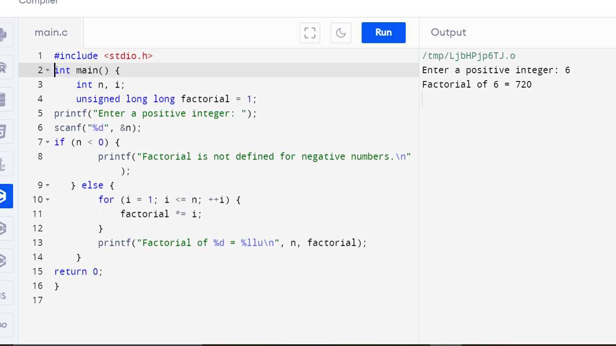

1. Write a c program to find factorial of given number with recursion.

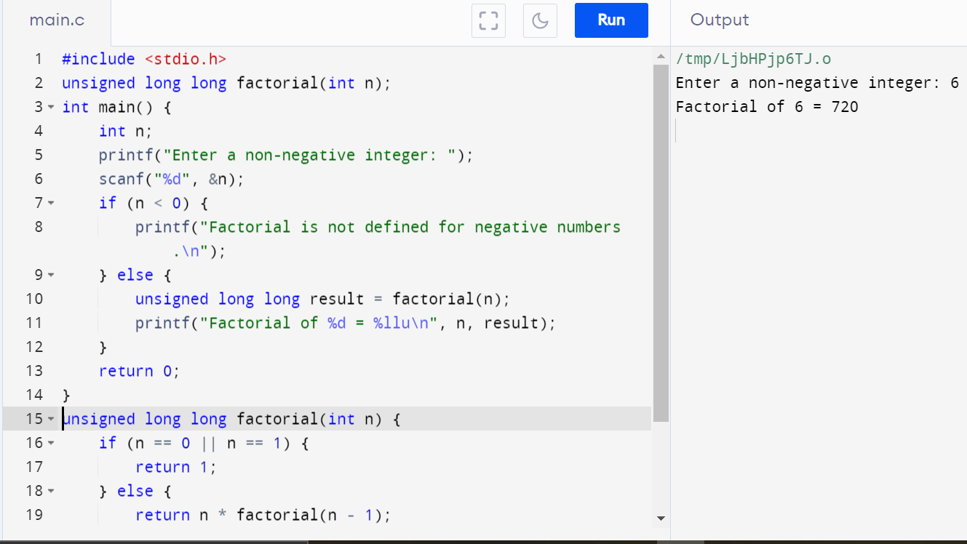

1. Write a c program to generate Fibonacci series without recursion.

1. Write a c program to generate Fibonacci series with recursion.

1. Write a c program to search element in an array using linear search.

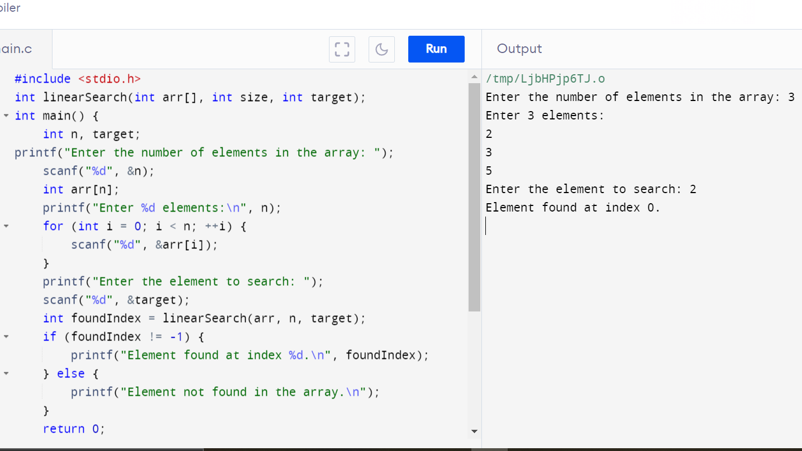

1. Write a c program to search element in an array using binary search.



